NAME: AJAY K

ROLL NO: CH.EN.U4CCE22003

Single Inheritance

Program:

Output:

Multilevel Inheritance

Program:

Output:

Hierarchical Inheritance

Program:

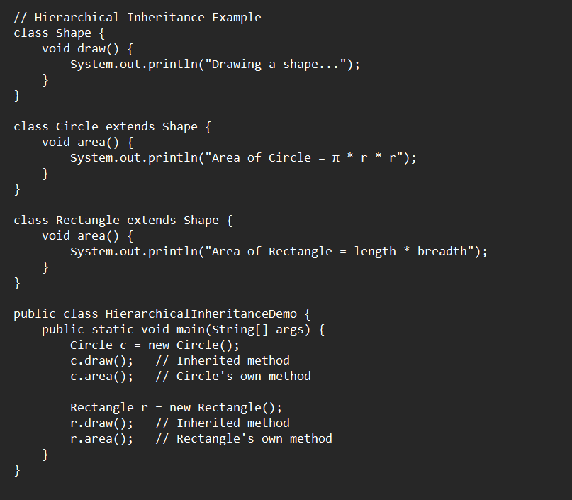

Output:

